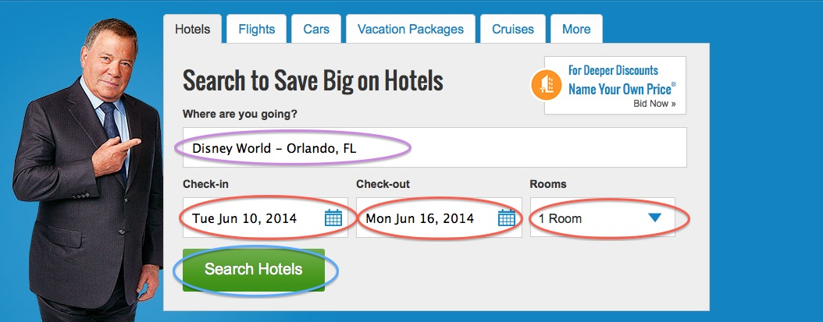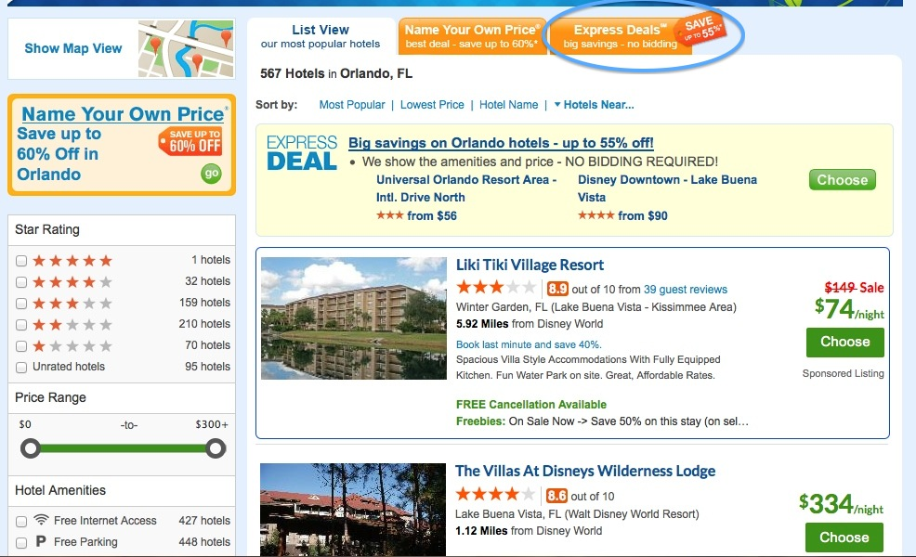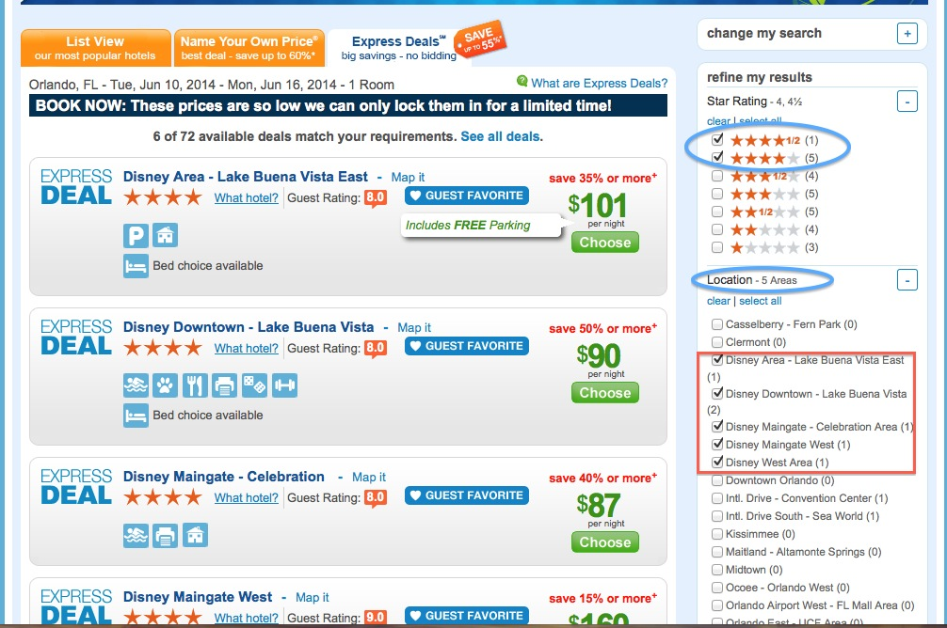

**Luyao Zhang**

**3/20/2014**

June – July 2014

Travel in the U.S.

**Walt Disney World in Orlando, Florida**

**Website:** [**https://disneyworld.disney.go.com/**](https://disneyworld.disney.go.com/)

**This website has everything. You can decide where you want to stay by browsing this website, but when it comes to making a reservation…**

**PRICELINE!!**

**I used the “express deals” function on this website and successfully booked myself a room at Marriot in New Orleans for only 80 buck/day! (This is like at least a 50% discount compared with list price)**

**And I’ll show you how to do it:**

**1. Go to** [**www.priceline.com**](http://www.priceline.com) **and choose the region where you are staying, date of check-in and check-out, and of course, the # of rooms you want. When you fill all these out, click on the green button “Search Hotels”.**

**2. After you click “search hotels”, this is what you are going to see. Notice the orange button I marked with a blue circle; it says “Express Deals”. Well, what are you waiting for? Just click on it hard!**

- 公司评价

**3. First they will show a list of hotels that are in Orlando, FL.**

**However, you need to further refine the results by being more specific about the Star Rating and Locations.**

**As your demands become more specific, the search results on the left will be updated simultaneously.**

**The picture here is what I get if I am looking for 4 or 4.5-star hotels in the Disney Area.**

**Note that you can only see the prices and the discounts, but not the names of hotels. This is the beauty of Express Deals; go wherever life takes you LOL**

**You don’t have to worry about the qualities of the hotels, because all hotels listed in here will meet your requirement.**

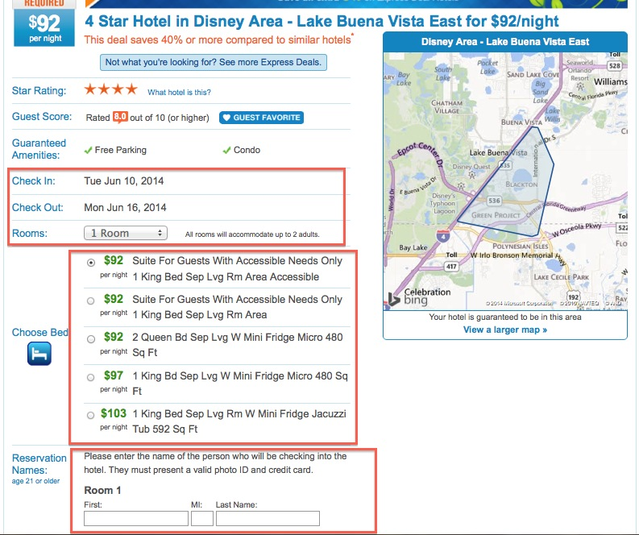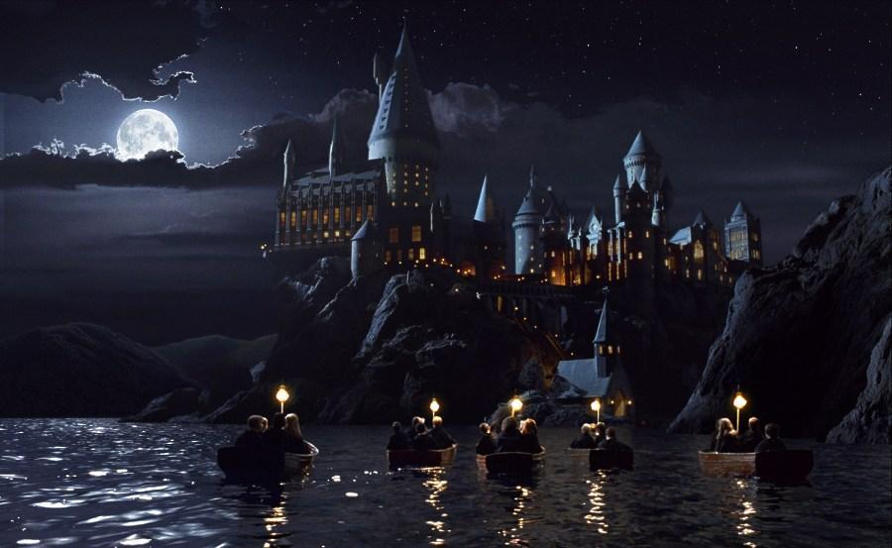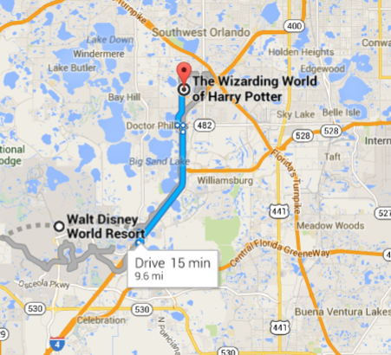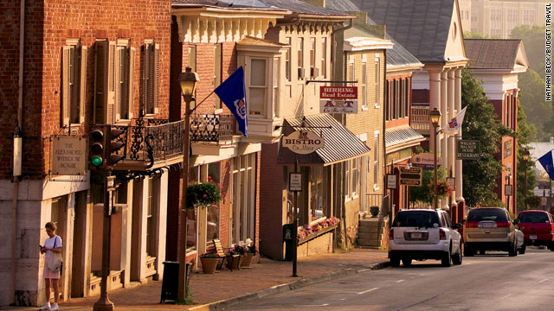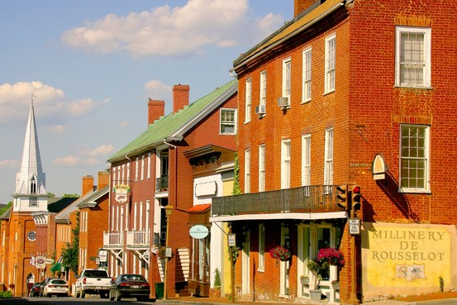

**4. Let’s say I picked the 1st hotel on the list. Then this is what I will see. You can change the # of rooms you want, and choose what kind of rooms you want. However, looks like you won’t be able to change dates of checking in and checking out.**

* **You are not always able to choose bed, though. If you don't see the option of choose bed, be careful, because chances are that you are going to be assigned a room after you arrive at the hotel, which means it’s not impossible that they will give you all just a single room…**

**So fill out everything you need to fill out, and make the payment and fill out your address and stuff (these are at the bottom of the page, which is not included in this snapshot).**

**Eventually, click the green button “Buy me hotel now”, which is also at the bottom of the page~~, and hope for the best~~. I mean, what could go wrong? It’s a 4/4.5-star hotel in Florida!**

**So, Harry Potter!**

**As you can see from Google Maps, it’s only about 15 minutes drive from The Walt Disney World Area to the HP theme park. If you are going to rent a car (and please do), it’s going to be fairly easy to get there.**

**Lexington, Virginia**

**My reasons: so when traveling overseas, you always want to experience something that you don’t see that often in your country.**

**Well, two things I can think of that are not commonly seen in Australia might be Civil War flavored towns and black people. I guess you’ll see quite a lot of the latter during your stay in Florida, so I strongly recommend that you spend the second week to experience the former.**



**Where to go then?**

**Washington and Lee University**

* Hey, remember on Wechat I also recommended Maine, because it has cheap lobsters? Then I figured that for Australians, this might actually be the reason why they won’t take a vacation there. However, do let me know if you are still interested.

**If you want to plan a civil war trip, here’s the website that you are probably going to find helpful:**

[**http://www.civilwartraveler.com/EAST/VA/va-valley/pike2.html**](http://www.civilwartraveler.com/EAST/VA/va-valley/pike2.html)

**However, if you are like me, who only wants to enjoy the atmosphere and having fun, this is the page you may want to explore a little bit:**

[**http://travel.yahoo.com/p-travelguide-480053-lexington_vacations-i**](http://travel.yahoo.com/p-travelguide-480053-lexington_vacations-i)

**Or, you guys can just come to Chicago, and maybe spend a day or two in Champaign-Urbana.**

**I mean screw Lexington; we are the land of Lincoln. How civil war is that, mate? ;)**